Every Foot Locker brand store , Ladies, Kids, Champs, etc has a specific set of lights that goes with the design concept of the store.

Over the years, corporate will roll out different design concepts. Some decades ago, the KIDS foot Locker cashwrap looked like a larger foot ball.

With each concept, the lights change.

At this time, both the House of Hoops and also the Fly Zone have mini-track heads, typically 20 watt Metal Halie or the LED equalivent. The House of Hoops has been around longer and has a lot of 20 watt MH lights.

We can replace them with new LED lights.

The two options are the LF Illuminations, TXA01-B in the color to match. Or the

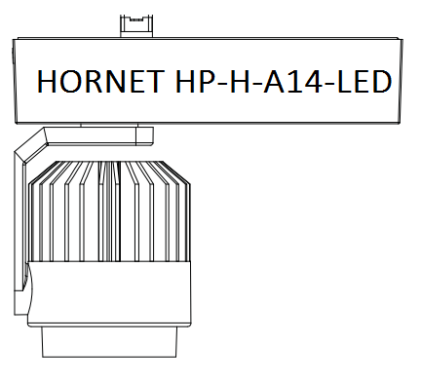AMERLUX Hornet HP-H-A14-LED.

The Amerlux looks more like the existing lights, but has a long lead time. Amerlux makes lights to order so 2-3 weeks is not uncommon.

At the time of this writing, Capitol has about 100 of the LF Illumination TXA01-B in stock.

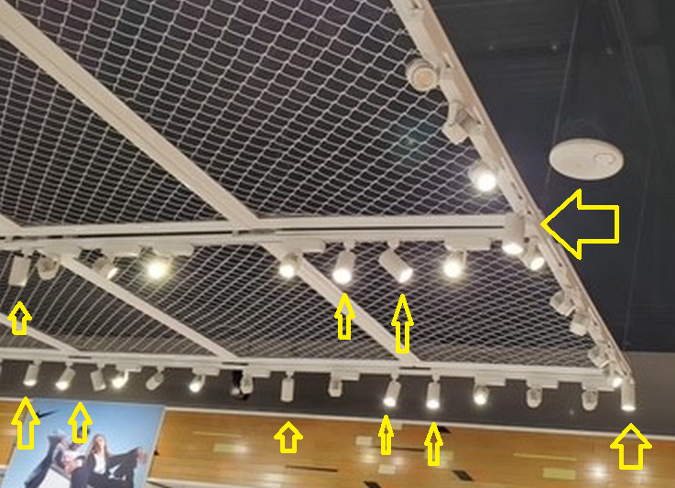

Here is a flyzone with the LF ILLUMINATION fixtures. You would have to be very astute to pick them out if you were just shopping.

Since the HORNET are made by Amerlux, the are almost a direct replacement. The LF Illumination fixtures do look different, but the ‘noise’ of so many lights, makes this work.